Warm up Problem 1: Analysis
A jet aircraft employs a system for monitoring the rpm, pressure, and temperature values of its engines using sensors that operate as follows:
- P sensor output = 0 only when pressure < 220 psi
- RPM sensor output = 0 only when speed < 4800 rpm
- T sensor output = 0 only when temperature < 200°F
Figure below shows the logic circuit that controls a cockpit warning Light for certain combinations of engine conditions. Assume that a HIGH at output W activates the warning light.
Determine what engine conditions will give a warning to the pilot.
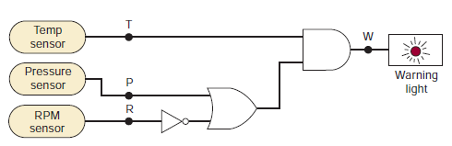
T | P | R | Warning
0 | 0 | 0 | 0
0 | 0 | 1 | 0

Warm up Problem 1: Logic Design

Design a logic circuit that controls an elevator/ building lift door in a three-story building. The circuit has four inputs as a logic signal that indicates
When the elevator is moving (M= 1) or stopped (M= 0).
F1, F2, and F3 are floor indicator signals that are normally LOW, and they go HIGH only when the elevator is positioned at the level of that particular floor. For example, when the elevator is lined up level with the second floor, F2 = 1 and F1 = F3 = 0. The circuit output is normally LOW and will go HIGH when the elevator door is to be opened.
Real life problem: Actual implementation
A float switch is used to detect water level in tank. The switch is open when water level in the tank is below “Tank full level”, and switch is closed when water level reaches to “Tank full level”. Design system to sound alarm when tank is full and LED indication to give visual indication of tank full. Make provision to stop irritating buzzer sound when tank is full. The system should be battery operated.
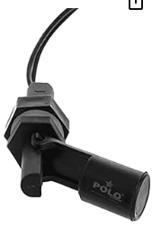




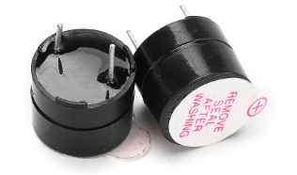
5V Active Electromagnetic Buzzer
Input Voltage(Max.) : 5V
Resistance: 90 Ω
Resonance Frequency: 2048 Hz
Sound pressure(dB(A)/10cm)min.: 80
Electronics design Real life problem
Design a system which has input of step down transformer with 6V AC output.
- Generate 50Hz Square wave output which is suitable to drive clock of D flip flop based digital system.
- Generate 50Hz Square wave output with very low duty cycle which is suitable to drive interrupt of microcontroller.
Digital system design real life problem
Figure shows a 7406 open-collector inverting buffer used to control the ON/OFF status of an LED to indicate the state of FF output
The LED’s nominal specification is at VF = 2.4 V, IFnominal = 20 mA, and IF(max) = 30 mA.
(a) What voltage will appear at the 7406 output when Q = 0?
(b) Choose an appropriate value for the series resistor for proper operation.

In Figure below the 7406 output is used to switch current to a relay.
(a)What voltage will be at the 7406 output when Q = 0?
(b)*What is the largest current relay that can be used? Find suitable relay
(c) How can we modify this circuit to use a 7407?

Figure 8-57 shows a 74LS193 counter with its active-HIGH master reset input activated by a push-button switch. Resistor R is used to hold MR LOW while the switch is open. What is the maximum value that can be used for R?
(b) Repeat part (a) for the 74ALS193.
Design a system which has input of step down transformer with 6V AC output.
- Generate 50Hz Square wave output which is suitable to drive clock of D flip flop based digital system.
- Generate 50Hz Square wave output with very low duty cycle which is suitable to drive interrupt of microcontroller.

Sol:

6Vol AC should generate Gnd to Pick 6V *√2= 8.48V

Design a circuit to indicate microcontroller that temperature has crossed above 80DC. Use semiconductor temperature sensor. Data Microcontroller is not having on chip ADC.

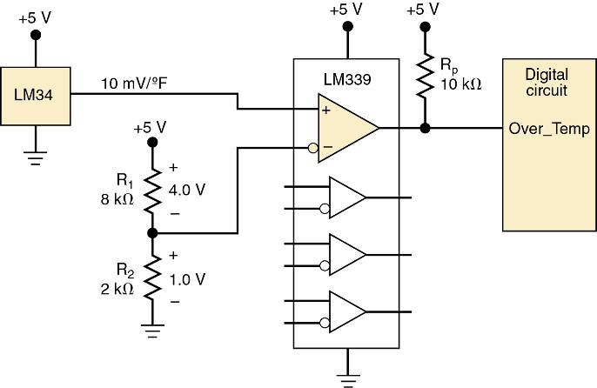

Design a level translator for a microcontroller which is operating at 1.8Volts. The RMP pulses coming from wheel are LS TTL compatible:

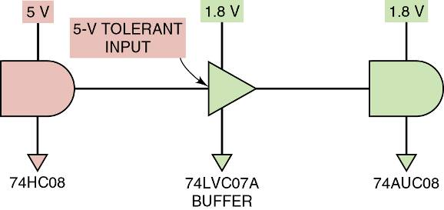

A substantial shift in voltage because driver & load operate on different supply voltages requires a voltage-level translator interface circuit. Study data sheet of 74LVC7A buffer

